SQL – Joins: inner, outer; Sub queries

WEEK 8

1. **Using nested query retrieve the names of all employees who have two or more dependents.**

SELECT LNAME , FNAME FROM EMPLOYEE WHERE ( SELECT COUNT ( * ) FROM DEPENDENT WHERE SSN = ESSN ) >=2;

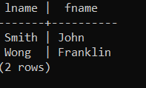

1. **Using nested query Retrieve the name of each employee who has a dependent with the same first name and is the same sex as the employee.**

SELECT E.FNAME, E.LNAME FROM EMPLOYEE AS E WHERE E.SSN IN (SELECT ESSN FROM DEPENDENT WHERE E.FNAME = DEPENDENT_NAME AND E.gender = gender);

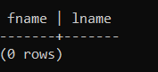

1. **Using nested query retrieve names of employees whose salary is greater than the salary of all the employees in department 5.**

select fname, lname from employee E where E.salary > (select max(salary) from employee where dno=5);

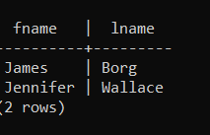

1. **Retrieve the names of employees who have no dependents.( use Exists/Not Exists)**

select fname, lname from employee E where not exists (select essn from dependent D where D.essn = E.ssn);

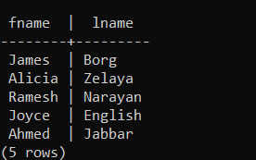

1. **List the names of managers who have at least one dependent.**

select fname, lname from employee E inner join department D on E.ssn=D.mgr_ssn inner join dependent p on E.ssn=essn group by fname, lname;

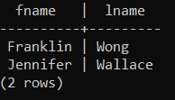

1. **Using natural Join retrieve the name and address of every employee who works for the ‘Research’ department.**

select fname, lname, address from employee natural join (select dname, dnumber as dno from department where dname='Research') as dep_research;

